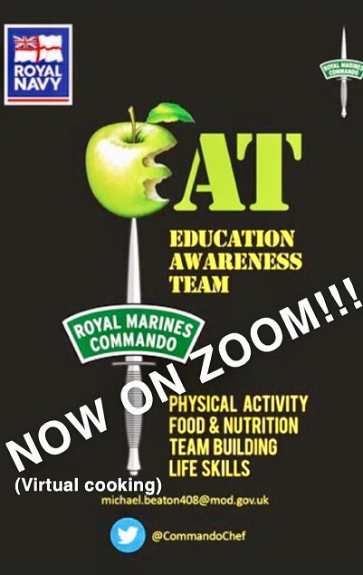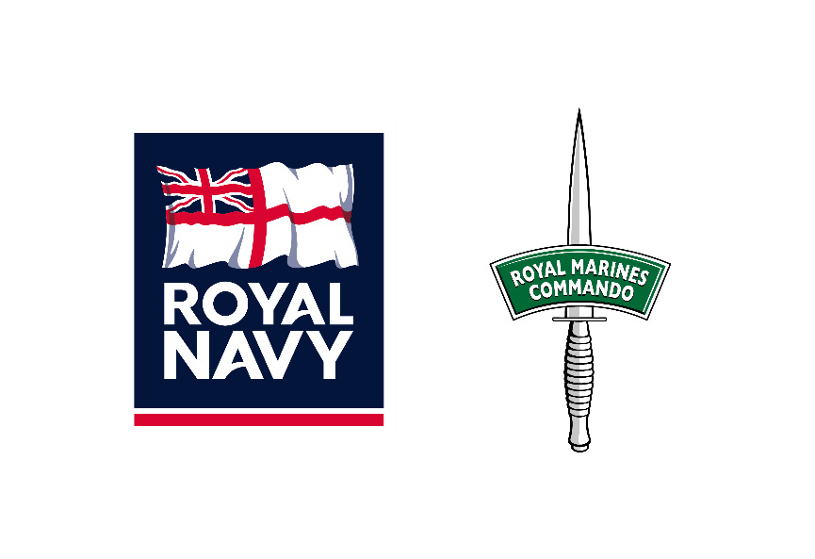

RM-EAT
ROYAL MARINES – EDUCATION AWARENESS TEAM

Information sheet on what RM-EAT has to offer to educational establishments, all sports, cadets, scouts etc. both male and female aged 14+.
RM-EAT comes in two formats in this virtual world –

Presentation – Audience is watching, I deliver - Introduction, Live Cooking, Food and Nutrition Advice, Royal Navy/Royal Marines Career Opportunity’s, Sugar in Energy Drinks, Life Story, Questions and Chat.
Workshop – Audience is Cooking under my guidance and instruction. List of ingredients and equipment plus handy hints is sent out to the teacher/tutor/coach beforehand to source and get ready. Also delivered is Royal Navy/Royal Marines Career Opportunity’s, Questions and Chat.

The HOST controls the ZOOM invite and each programme last 35 mins approximately due to ZOOM time constraints. DBS cleared.

If interested email –
Michael.Beaton408@mod.gov.uk
Regards
Mike Beaton – Royal Marines.

